**KARAMU TRAIL TRACK**

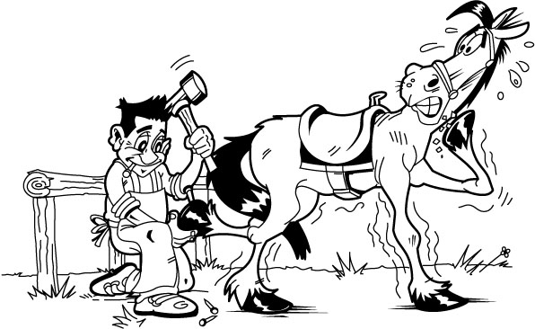

**School and Youth Group**

**Risk Analysis and Management**

Horse Riding

You are in primary control of the horse and your safety depends on your ability to remain balanced on a moving animal and carry out simple instructions to steer and halt. Allowing your horse to trot or canter increases your chances of falling off and could cause another persons horse to start trotting or cantering to catch up. A horse may suddenly stop, change direction or speed. We do take all care as to ensure your safety; however, injury may result from participation in any horse riding activity. All treks are accompanied by experienced adult guides who are easily identifiable by day-glo visibility jackets.

**Teachers and parent help** should offer pastoral support to children who find horse riding daunting. However they are not usually able to help with supervising horses on a trek, unless they have previous experience riding a horse and leading another horse at the same time. The trekking guidelines require one guide for each ten riders as a minimum and one guide for each five riders if practicable. We always meet the minimum guidelines and aim to exceed them whenever possible.

Basic riding instructions are given verbally and demonstrated by a guide prior to leaving on the trek. Students should listen carefully and endeavour to follow the instructions to the best of their ability.

**Emergency Stop**

Hold on as best you can with your legs and hands, keep your seat deep in the saddle. Hold the reins close to the horses’ mouth and pull back, and back and back. If the horse still does not stop then pull on one rein to steer your horse in a small circle.

**Risks – Horse Riding**

|  |  |
| --- | --- |
| Losing balance and falling or being thrown from a height of one to two meters. Most falls do not result in more than bruises but can result in broken bones and/or concussion. | **Wear a safety helmet**  Helmets are supplied by us. Fit yourself with a helmet that is not too tight and hurts and not so loose that it flops around when you shake your head. Fasten the helmet firmly under your chin.  If falling – tuck your head in and roll. |
| Feet being stepped on while on ground. | **Wear strong closed in** **shoes** and watch where you put your feet. |
| Blisters from holding reins or saddle. | Avoid holding on too tightly. |
| Chafed Legs from stirrup leathers and riding close to bushes. | **Wear full length trousers made of a soft flexible fabric.** |
| Sunburn. | **Wear sunscreen.** |
| Being kicked. | When on the ground take care not to walk behind horses, when riding take care not to ride your horse too close to others. |
| Dehydration, hypothermia and heat stroke. | Ensure that you bring water to drink and utilise the shade when required. Wear clothing appropriate to the weather. Bring a raincoat and jersey. |
| Colliding with a tree, tree branch, fence or other obstacle. | Watch where you are going and steer your horse around obstacles. |
| Insect and bee stings. | Designated first aid person to be aware of any children who have serious allergies and carry the appropriate treatment. |

**First Aid**

The accompanying teacher or parent help are required to hold a first aid certificate and take care of children’s first aid requirements. This person must make themselves known to the guides on arrival and be prepared to deal with bruises, sprains, concussion, broken bones, blisters, sunburn, etc. Any child who falls off or is otherwise hurt must be spoken to and examined by the designated first aid person. Note: cell phone reception is variable in this area.

Canoes

The canoes are on a shallow self contained small lake. The canoes are very stable but can be overturned with vigorous movement. Lifejackets and buoyancy aids are provided. Wear appropriate light clothing for a water activity. One shore based guide will be made available to assist with getting children in and out of canoes and that checking life jackets are worn. The school is to supply the remaining number of required adult supervisors for water activities, including someone with a life saving certificate should the school require this.

**Risks – Canoes**

|  |  |
| --- | --- |
| Falling out into the lake. | Wear a life jacket or buoyancy aid and remain seated while in the canoe. |
| Being hit with a paddle. | Take care to keep your paddle away from other people and be aware of others. |
| Fingers squashed between boats. | Keep your hands inside the canoe. |
| Sunburn. | Wear sunscreen and sunhat. |
| Hypothermia, heatstroke. | Wear clothing appropriate to the weather. Bring a change of clothes and a towel. |

Emergency meeting point

In the event of an emergency, the meeting point is the car park.

Supervision of children

Karamu trail track staff supervise the activities, make safety equipment available, give instructions, guide the treks, ensure the horses stay with the trek and report any behaviour of concern to the staff responsible for the group. Karamu trail track staff are not police vetted and do not take on responsibility for the supervision or care of children.